Rutgers Business School
Management Information Systems (33:136:370)
Instructor: Disha Parkhi
Unary Relationships

Solution to the Database Design Exercise – Part 1:
The difficult part here is how to store the supervisor information. We need to create a correspondence between each employee and his or her supervisor who happens to be another employee. The solution is to have a foreign key inside of EMPLOYEE to EMPLOYEE:

LOCATION (LocationID, Name, Address, City, State, Zip, Phone)

TITLE (TitleID, Name, Description, EdRequired, MinSalary, MaxSalary)

EMPLOYEE (EmployeeID, FirstName, LastName, Salary, Gender, Rating, LocationID, TitleID, SupervisorID)
LocationID foreign key to LOCATION
TitleID foreign key to TITLE
SupervisorID foreign key to EMPLOYEE
This is totally fine. Remember that the annotation “x foreign key to Y” means that “the value of attribute x of each record in this table (the one where the foreign key is) should equal the value of the primary key of some record in table Y.” There is no restriction that Y has to be a different table. So, “SupervisorID foreign key to EMPLOYEE” means that the value of SupervisorID in each record in EMPLOYEE must match the value of the primary key of some (presumably different) record in EMPLOYEE. This kind of situation is called a unary relationship, and is drawn as shown above. That is, the EMPLOYEE table is in a one-to-many relationship with itself.
If an employee does not have a supervisor, then we leave the SupervisorID field blank – in this case, only the CEO is in this situation.

Incorrect solution: creating a table SUPERVISOR for the supervisors.

EMPLOYEE(EmployeeID, FirstName, LastName, Salary, Gender, Rating,LocationID, TitleID, SupervisorID)
LocationID foreign key to LOCATION
TitleID foreign key to TITLE
SupervisorID foreign key to SUPERVISOR

SUPERVISOR(SupervisorID, FirstName, LastName, Salary, Gender, PerfRating, LocationID, TitleID,)

We could think of creating a table where we store the employees and another separate table where we store the supervisors, but supervisors are employees, and supervisors have supervisors as well (except the CEO), so the same person would be showing up in both tables, which is agains the database design rule of not storing the same information in more than one place. To get around this problem, we could have a foreign key pointing back to EMPLOYEE, as in

SUPERVISOR(SupervisorID, EmployeeID)
EmployeeID foreign key to EMPLOYEE

This setup essentially directs one back to EMPLOYEE table to find specific information about a supervisor, and results in the following rather peculiar ER diagram:

This diagram shows a second one-to-many relationship between EMPLOYEE and SUPERVISOR, reversed from the original one, because that is literally what having an EmployeeID foreign key in SUPERVISOR means. The result is rather strange, and conceivably we could have several entries in SUPERVISOR pointing to the same employee. That would mean that several different “supervisors” in the SUPERVISOR table were actually the same person, which could cause problems. This problem can be fixed though, as it is explained next.
A correct but unnecessarily complex solution:
To fix the problem mentioned above, where we could have a supervisor being associacted with multiple employees, we can enforce uniqueness of EmployeeID in SUPERVISOR by making it the primary key. We wouldn’t need SupervisorID in SUPERVISOR anymore, and we would get the following design:

EMPLOYEE(EmployeeID, FirstName, LastName, Salary, Gender, Rating, LocationID, TitleID, SupervisorID)
LocationID foreign key to LOCATION
TitleID foreign key to TITLE
SupervisorID foreign key to SUPERVISOR

SUPERVISOR(EmployeeID)
EmployeeID foreign key to EMPLOYEE

That is, we created a subtype…

This solution works but it is overly complicated. There are no additional fields stored in the subtype SUPERVISOR, beyond the primary key, so the only function of the SUPERVISOR table is to identify which employees are supervisors. But this information is already available elsewhere in the database by just by scanning through the EMPLOYEE table and just checking what distinct values appear in the SupervisorID field… Using a unary relationship is much simpler.

Setting Up a Unary Relationship in Access
Next, we create the unary relationship. The procedure of creating a unary relationship is quite similar to creating multiple relationships between the same pair of tables. After creating the “regular” relationships between Location, Employees, and Title, we drag table EMPLOYEE again to the relationship window. Access will it “Employees_1”. Finally we link the SupervisorID field in the Employees table with the EmployeeID field in the Employees_1 table, and enforce referential integrity. The relationship window will look like:

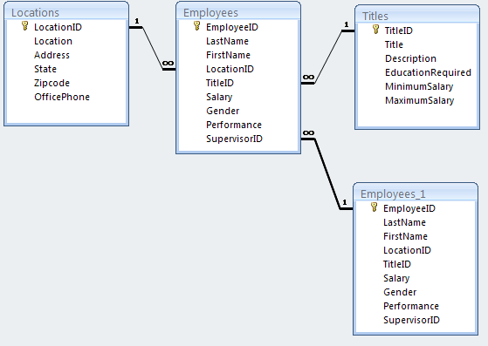
That is all we need to do. In the properties of the SupervisorID field of the Employees table, note that the “required” property is set to “no” to allow some employees (like the CEO) not to have a supervisor; allowing a blank field does not interfere with referential integrity, which is enforced only if the foreign key field is non-blank.

Solution to the Database Design Exercise – Part 2:
If an employee can have more than one supervisor, then we do not have a one to many relationship between EMPLOYEE and itself, but a many to many relationship.
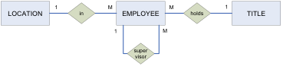

M

LOCATION (LocationID, Name, Address, City, State, Zip, Phone)

TITLE (TitleID, Name, Description, EdRequired, MinSalary, MaxSalary)

EMPLOYEE (EmployeeID, FirstName, LastName, Salary, Gender, Rating, LocationID, TitleID)
LocationID foreign key to LOCATION
TitleID foreign key to TITLE

SUPERVISOR (SuperviseeID, SupervisorID)
SuperviseeID foreign key to EMPLOYEE
SupervisorID foreign key to EMPLOYEE

Solutions to the queries:

Create a query that shows the first name and last name of each person that has a supervisor, along with the first and last name of their supervisor.

SELECT Employees.FirstName, Employees.LastName, Supervisor.Firstname, Supervisor.LastName
FROM Employees, Employees AS Supervisor
WHERE Employees.SupervisorID = Supervisor.EmployeeID;

Note that each line of the output needs to contain information from two different employee records, one for the employee and one for the corresponding supervisor, therefore, we must join pairs of records from the Employees table in the FROM clause (this is the meaning of Employees, Employees), but giving the second record the name Supervisor using an AS modifier. The WHERE condition, namely Employees.SupervisorID = Supervisor.EmployeeID, ensures that the employee in the second record really is the supervisor of the employee in the first record. We could also have used INNER JOIN.
- Create the same query but now making sure that all employees show up.
SELECT Employees.FirstName, Employees.LastName, Supervisor.Firstname, Supervisor.LastName
FROM Employees LEFT JOIN Employees AS Supervisor
ON Employees.SupervisorID = Supervisor.EmployeeID;

The table from the query number 1 does not show the CEO, since he/she is not supervised (his foreign key is empty). To make the CEO show, we need to use LEFT JOIN.

- Show the first name, last name, job title, and number of people directly supervised for each person who directly supervises at least four people.

SELECT Sup.FirstName, Sup.LastName, Title, COUNT(E.EmployeeID) AS NumberSupervised
FROM Employees AS E, Employees AS Sup, Titles AS T
WHERE E.SuperVisorID = Sup.EmployeeID AND Sup.TitleID = T.TitleID
GROUP BY Sup.EmployeeID, Sup.FirstName, Sup.LastName, Title
HAVING COUNT(E.EmployeeID) >= 4;

For this query, we need to combine each supervisor with his/hers supervisees. Then we group the records by supervisor and count the records of each group, that is, the number of employees supervised by each supervisor. We need two records from Employees, one aliased to be called Supervisor, and one record from Titles, to supply the job title. In the GROUP BY clause, we include Supervisor.EmployeeID so that there is no possibility of two supervisors with the same name getting consolidated into a single group (although that does not happen in this specific dataset). Recall that we must also group by the other attributes that we’re displaying outside an aggregation function (Sup.FirstName, Sup.LastName, Title).

